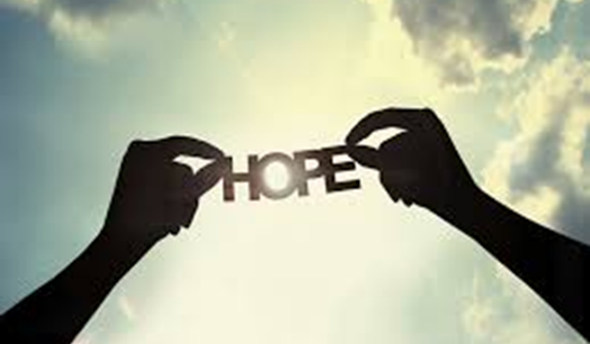
We Are People of Hope

By Tom East, Director, Center for Ministry Development

Easter is the season of resurrection. As Christ’s disciples, our lives should be a sign that God’s love is more powerful than any situation, any crisis, and any tragedy that we can encounter. We can be witnesses of hope.

Mini Retreat about Hope

Consider giving yourself a 30-minute retreat on Hope in this Easter season.

Step One: Pray that your heart be opened to God’s hope in hew ways.

Step Two: Read over the quotations about Hope below. Consider these questions:
- What speaks to you? What resonates?
- How would you define hope in your life?

Step Three: Reflect on one or more of these additional questions:
- How is my life a sign of hope? With whom do I share my hope?
- What helps me to be more hopeful? What robs me of hope?
- What is one concrete thing I can do to be an sign of hope for others this Easter season?

Step Four: Read Jeremiah 29:11 (NRSV)

For surely I know the plans I have for you, says the Lord, plans for your welfare and not for harm, to give you a future with hope.

Step Five: Share your hopes in prayer.
- What do I hope for? For myself, my loved ones, my community, and the world in which we live?
- What are things I can do within my roles to create possibilities for hope and God’s love to break through?

Proclaiming Hope

“The very least you can do in your life is to figure out what you hope for. And the most you can do is live inside that hope. Not admire it from a distance but live right in it, under its roof.”

Excerpt from Animal Dreams by Barbara Kingsolver

“Dietrich Bonheoffer once warned against cheap grace, and I warn now against cheap hope. Hope is not merely the optimistic view that somehow everything will turn out all right in the end if everyone just does as we do. Hope is the more rugged, the more muscular view that even if things don’t turn out all right and aren’t all right, we endure through and beyond the times that disappoint or threaten to destroy us.”

The Scandalous Gospel of Jesus: What so Good about the Good news? By Peter J. Gomes, 2007 (page 220)

“Hope is a state of mind, not of the world. Either we have hope or we don’t; it is a dimension of the soul, and it’s not essentially dependent on some particular observation of the world or estimate of the situation. Hope is not prognostication. It is an orientation of the spirit, an orientation of the heart; it transcends the world that is immediately experienced, and is anchored somewhere beyond its horizons….Hope, in this deep and powerful sense is not the same as joy that things are going well, or willingness to invest in enterprises that are obviously heading for success, but rather an ability to work for something because it is good, not just because it stands a chance to succeed. The more propitious the situation in which we demonstrate hope, the deeper the hope is. Hope is definitely not the same thing as optimism. It is not the conviction that something will turn out well, but the certainty that something makes sense, regardless of how it turns out.”
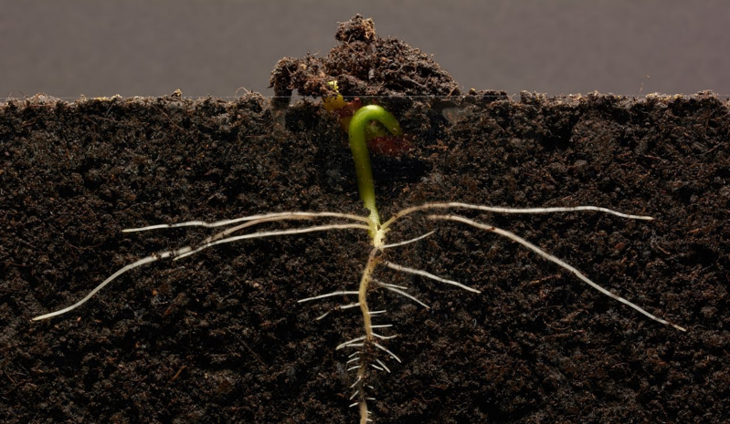
Disturbing the Peace By Vaclav Havel, 1986 (page 181)

“We always think of hope as grounded in the future. That’s wrong, I think. Hope is fulfilled in the future but it depends on our ability to remember that we have survived everything in life to this point—and have emerged in even better form than we were when these troubles began. So why not this latest situation, too? Then we hope because we have no reason not to hope.
Hope is what sits by a window and waits for one more dawn, despite the fact there isn’t an ounce of proof in tonight’s black, black sky that it can possible come.”
Joan Chittester’s Scarred by Struggle, Transformed by Hope

People say, what is the sense of our small effort.
They cannot see that we must lay one brick at a time, take one step at a time.
A pebble cast into a pond causes ripples that spread in all directions. Each one of our thoughts, words and deeds is like that.

No one has a right to sit down and feel hopeless.
There’s too much work to do.

Call to Gather by Dorothy Day

Jeremiah 29:11 (NRSV)

For surely I know the plans I have for you, says the Lord, plans for your welfare and not for harm, to give you a future with hope.

