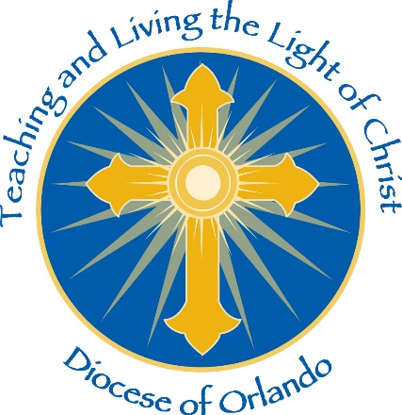

Assumption of Risk and Waiver of Liability Relating to Coronavirus/COVID-19

The novel coronavirus (“COVID-19”) has been declared a worldwide pandemic by the World Health Organization. COVID-19 is extremely contagious and is believed to spread mainly from person-to-person contact. As a result, federal, state, and local governments and federal and state health agencies recommend social distancing and have, in many locations, prohibited the congregation of groups of people.

The [PARISH NAME] (“Parish Name” or the “Parish”) has put in place preventative measures to reduce the spread of COVID-19; however, we cannot guarantee that you or your child(ren) will not become infected with COVID-19. Further, participation in [parish activity or event] could increase your child(ren)’s or your risk of contracting COVID-19.

By signing this agreement, I acknowledge the contagious nature of COVID-19 and voluntarily assume the risk that my child(ren) and I may be exposed to or infected by COVID-19 by participating in [parish activity or event] at Parish Name and that such exposure or infection may result in personal injury, illness, permanent disability, and death. I understand that the risk of becoming exposed to or infected by COVID-19 at Parish Name may result from the actions, omissions, or negligence of myself and others, including, but not limited to, School employees, volunteers, and program participants and their families.

I voluntarily agree to assume all of the foregoing risks and accept sole responsibility for any injury to my child(ren) or myself (including, but not limited to, personal injury, disability, and death), illness, damage, loss, claim, liability, or expense, of any kind, that I or my child(ren) may experience or incur in connection with my child(ren)’s participation in [parish activity or event] at Parish Name (“Claims”). On my behalf, and on behalf of my children, I hereby release, covenant not to sue, discharge, and hold harmless Parish Name and the Diocese of Orlando, and all of their current, former, and future agents, representatives, religious and employees and related entities (collectively, “the Diocese”) of and from the Claims, including all liabilities, claims, actions, damages, costs or expenses of any kind arising out of or relating thereto. I understand and agree that this release includes any Claims based on the actions, omissions, or negligence of the Diocese, its employees, agents, and representatives, whether a COVID-19 infection occurs before, during, or after or participation in [parish activity or event].

__________________________________ _________________________
Signature of Parent/Guardian Date

__________________________________ _________________________
Print Name of Parent/Guardian Name of Participant

